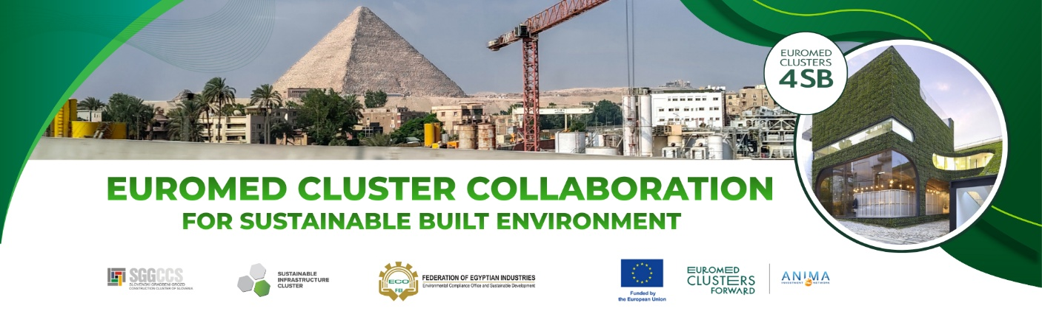
EUROMED4SB business mission to Cairo, Egypt
28-30th September, 2026
Mission application template
APPLICANT INFORMATION
Full name of the company
Industrial sector
Legal address
VAT registration number
Company website
Contact details of the representative attending the EUROMED4SB mission
Name surname
Email address
Phone number
Brief description of the company and its main activity area(s) in regard to sustainable building and construction
Motivation for applying for the EUROMED4SB Mission
Brief description of the purpose for taking part in the EUROMED4SB Mission.
Brief description of the company's expected outcomes from the EUROMED4SB mission
- I confirm to have read and understood the EUROMED4SB requirement for reimbursement of travel costs.
Travel cost reimbursement per participating organisation will be between 600 – 800 EUR, depending on the number of organisations participating, for up to 10 attending businesses per partner country (Slovenia, Poland). Attendance at the planned programme, a short report on impact, including at least one agreement or MOU initiated with a partner from Egypt, will be required to claim reimbursement.

Name of the entity representative_______________________
Date, Place_______________
Signature____________________________

